The Case for Cost Sharing

By
Mike Labello
Intermodal Transportation Specialist
Public Transportation Bureau
New York State Department of Transportation
Feb. 2012

Background

For the last thirty years, counties and small urban area cities in New York State have tried to improve mobility for their residents using evolving strategies with mixed results. In the 1980s-90s, the Rural Public Transportation Coordination Assistance program (RPTCAP) led to human service agencies (OFA, DSS, etc) effectively taking over a number of small public transportation systems. In 2004, the Federal Executive Order for United We Ride (UWR) and the subsequent Federal SAFETEA-LU legislation called for localities to prepare Coordinated Public Transit and Human Services Transportation Plans to coordinate local transportation services and funding. Through these efforts Federal, State and Local governments tried to provide efficient, affordable and reliable mobility services to their constituents. Yet, with the impacts of the current recession shrinking government revenue at all levels, transportation services are receiving less resources at a time when demand for community mobility, for employment, medical care and due to the general aging of the population, continues to grow.

Cost sharing is a process of fairly and logically determining, and then distributing among two or more benefactors, the costs of a coordinated and managed transportation system. The objective is to use current resources more efficiently and to then utilize the savings from those efficiencies to meet unmet needs. The objective, to maximize use of existing resources, is in line with the United We Ride concepts to develop a “family of services” to serve local mobility needs and to inventory existing resources as a first step in coordination. However, neither of these actions, by themselves, actually results in a planning process to identify resources, services, agreements and working relationships to address cost sharing in a hands-on fashion. Before getting into the details of cost sharing methodology, it’s important to distinguish between a public transportation program and a community mobility program.

Public Transportation Program - Public transportation is generally defined as a shared-ride service involving the transportation of passengers by means of rail, subway, buses, motor vehicles, or other means of mass conveyance generally associated with or developed for mass transportation of the public. Typically, federal funding for public transportation is leveraged with state and local dollars supporting the fare paying customer.

Community Mobility Program – A community mobility program is the combined efforts and use of resources and infrastructure of all public, private and human service agencies within a community or region that have a common mission of moving people from place to place. The funding for this is derived shares from the partners whose customers are utilizing the services.

The definition of public transportation in its basic form is “open to the public”, and therefore, the public services are used by any and all agencies, as it should be. Public Transportation is a critical resource in a community that needs to be used to its maximum potential. However, it is a single program; one of many in a community that has a mission to move people, and is often the only service thought of when needs are unmet and a solution is required.

Whereas creating a community mobility program is rarely considered in the local coordinated planning process. As a result, the costs and benefits of a mobility program is not evaluated in terms of cost sharing, service or infrastructure, which contributes to its lack of consideration as a solution. However, human service agencies, within an undefined “Mobility Program”, are providing or outsourcing rides, but seldom are evaluated as a possible solution to mobility needs because these agencies would charge “at cost” prices, while public transit services would only charge “fare”.

Compounding the desire to find mobility solutions is the pressure on agencies to cut operating costs. This breeds a search for a way out of bearing transportation costs rather than looking for a sustainable solution. The combination of growing mobility needs, shrinking staff and tightening public transit funding exacerbates the problem. Understanding the inclination of agencies to seek short term cost savings is important because often the development and institutional change necessary to consider cost sharing will fall short for lack of full disclosure by agencies. It is critical to note this planning process is not just a public transportation study; it should include a complete assessment of a community mobility program.

That human service agencies shift as many riders as possible to public transportation services is based on the idea the ride cost is the fare, and, thus, it is the most economical option available. While this looks nice on their budget sheets, the human service agencies can leave unclaimed federal program revenue that now has to be covered with state and local funds to balance the public transportation budget. Further compounding this situation are agencies which remain in the business of transporting clients, who can’t ride public transit, and hence continue to duplicate services, purchase capital equipment, and operate services from within their silos.

A community mobility program is an untapped opportunity, and if fully evaluated to identify its possible shared alternatives, would give everyone more choices.

The benefits are clear:
- Reduced infrastructure through collaboration
- More mobility choices without the need for unnecessary expansion
- Budget stabilization or reduction potential
- Freed up resources, avoiding costs of service expansions and staffing needs.

Peripheral benefits to this holistic approach include:
- Possible easing layoff concerns
- Gaining more local control over their own destiny
- Promoting greener communities

Despite its advantages, a community mobility program can be undermined by an inadequate planning process that postpones involvement of key decision makers until the end, when their approval is needed. This avoidable situation can sacrifice the hard work invested into evaluating the full potential of a community mobility program. Therefore, a thorough assessment is best achieved with the full support of the governing body of the local communities (legislatures, supervisors, or council members), so the creation of an ideal plan among all participants is supported and even encouraged to take place. The mission of a broad multi-agency assessment is to educate local decision-makers of the potential benefits of cost sharing. But, true education cannot be realized without full disclosure of agencies’ mobility practices and budget details. A comprehensive effort is easier sold as a discovery process which deserves to run its full course, without prejudging the outcome.

Requirements

Before a cost sharing methodology can be undertaken, a detailed assessment of existing services, infrastructure, costs, and funding will need to be documented in detail. This is often achieved through a study process that digs down into organizations, and when completed, should accurately provide a total cost of all services on an annual basis, the total fleet requirements of agencies (owned or outsourced), all technologies in use, various dispatch and trip planning processes in-place, and a detailed service area including days and hours of individual and potential services for coordination.

Upon completion of this assessment, the process should compile a coordinated vision based on the most perfect scenario, that being the total agreement and cooperation from all agencies operating mobility services. Skeptics will tell you a community mobility scenario cannot be achieved, but a thorough study is needed, because decision makers need to be educated on the best possible use of services that benefit agencies’ missions and uses tax dollars efficiently. Anything less is not empowering them to see all options and opportunities before them. The planning process does not presuppose a commitment to a mobility program; it’s an educational or discovery process. The open collaboration will eventually evolve into a final plan, at which time, a final cost sharing methodology that may provide a path to adopt a community mobility program for future implementation.

After the education process is complete, an actual plan for a mobility program can take shape and discussion of the terms of service delivery can begin. This is a negotiation process with stakeholders, decision makers, and experienced facilitators. In order for full-disclosure and inter-agency understanding to occur, it is recommended the process include developing rules or a memorandum of understanding to guide creation of a partnership. This would help avoid or resolve conflicts, give cohesion to the mobility program, and detail its mission. Three documents are developed in this phase:

- Partner By-Laws - The internal rules of the mobility program.
- Program Policy – The principle rules that guides decisions and rational.
- Program Minimum Requirements – Functional and physical performance minimums.

Cost Sharing Methodology

The following model assumes all work previously described was performed, with the result that multiple partners agreed they would benefit from forming a community mobility program. The next step is to review how they are funded as separate agencies, in comparison to a consolidated transportation entity.

Case Study: Mobility Program Cost Share

Current Stand Alone Services
Table 1, below, indicates the results of an assessment of services involving six (6) agencies that currently provide individualized client specific mobility services. While they collaborate very little regarding their missions and how they could be more efficient, this is in fact an unrecognized and undefined mobility program. In its current state, they combine for over $6 million in annual operating expenses; and provide 180,000 rides while travelling over 1,500,000 miles, while utilizing a total of 62 vehicles.
Table 1
People Movers Identified: | # Of Veh. | Current Budget | Total Budget % | Annual Riders | Total Riders% | Annual Miles | Total Miles%
Public Transportation Service | 13 | $950,000 | 15.73 | 21,348 | 11.86 | 315,900 | 20.90
Dept. Social Services (DSS) | 16 | $1,700,000 | 28.15 | 42,894 | 23.83 | 548,600 | 36.29
Rehabilitation Center (ARC) | 24 | $2,100,000 | 34.76 | 91,962 | 51.09 | 523,900 | 34.64
Dept. Mental Health (MH) | 5 | $1,100,000 | 18.21 | 16,218 | 9.01 | 84,500 | 5.59
Office for the Aging (OFA) | 3 | $125,000 | 2.07 | 5,112 | 2.84 | 15,600 | 1.03
Local Veterans Association | 1 | $65,000 | 1.08 | 2,466 | 1.37 | 23,400 | 1.55
Totals | 62 | $6,040,000 | 100.00 | 180,000 | 100.00 | 1,511,900 | 100.00

Exhibit “A”

Exhibit A is a view of the percentages of passengers and miles currently making up the undefined mobility program above. This research will be instrumental in determined cost sharing methodology based on levels of services needs.

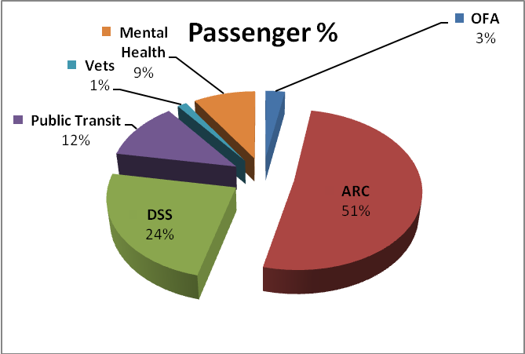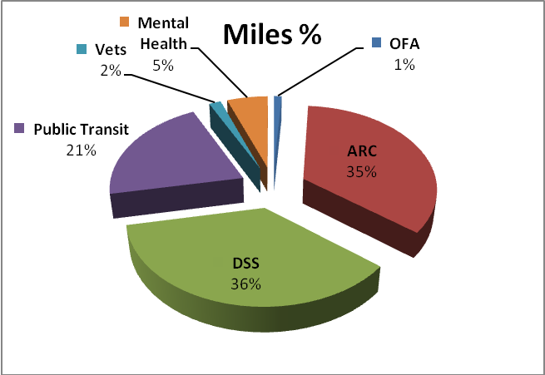

Shared Services Mobility Program
Table 2, below, indicates the results of developing baseline service delivery from all needs identified within the partnering agencies. The mission is to share rides and dollars for the delivery by one consolidated transportation service to move all people. All infrastructure and resources are now on the table to be used in a manner that can meet the needs of the partners; by doing so in a less duplicative and costly way, while fulfilling agency missions. Collaboration in this manner produces a community mobility program whose costs are $1.5+ million less, the number of vehicles is reduced by more than 30 percent and miles decline by nearly 23 percent.

Table 2
Partners Identified: | Veh | Current Budget | Annual Riders | % | Annual Miles | %
Public Transportation Service | S  H  A  R  E  D | S  H  A  R  E  D | 21,348 | 11.86 | 243,485 | 20.90
Dept. Social Services (DSS) |  |  | 42,894 | 23.83 | 422,196 | 36.24
Rehabilitation Center (ARC) |  |  | 91,962 | 51.09 | 403,323 | 34.62
Dept. Mental Health (MH) |  |  | 16,218 | 9.01 | 65,007 | 5.58
Office for the Aging (OFA) |  |  | 5,112 | 2.84 | 12,233 | 1.05
Local Veterans Association |  |  | 2,466 | 1.37 | 18,756 | 1.61
Totals | 43 | $4,500,000 | 180,000 | 100.00 | 1,165,000 | 100.00

Cost Sharing a Mobility Program

Cost sharing is a local decision and the methodology that is applied should take into account leveraging all federal dollars first and foremost before state and local dollars need to be expended. The reason is to not leave any federal revenue unclaimed by the program, to avoid unnecessary tax burden on state and local governments. For purpose of this case study, we will use a simplified methodology of fifty percent (50%) of budget applied to rider percentages and fifty percent (50%) of budget applied to mile percentages (as shown in Exhibit 1 above). These numbers are variables in an evolving program, and require a periodic reassessment to ensure an equitable distribution of costs. Table 3 below is the cost by agency assessment for a new mobility program sharing resources at a projected cost of $4.5 Million.

Table 3
Partners Identified: | Rider  % | 50% Cost | Mile  % | 50%  Cost | Total Cost Share | Prior  Cost | +/-
Public Transportation Serv. | 11.86 | $266,850 | 20.90 | $470,250 | $737,100 | $950,000 | 22%
Dept. Social Services (DSS) | 23.83 | $536,175 | 36.24 | $815,400 | $1,351,575 | $1,700,000 | 20%
Rehabilitation Center (ARC) | 51.09 | $1,149,525 | 34.62 | $778,950 | $1,928,475 | $2,100,000 | 8%
Dept. Mental Health (MH) | 9.01 | $202,725 | 5.58 | $125,550 | $328,275 | $1,100,000 | 70%
Office for the Aging (OFA) | 2.84 | $63,900 | 1.05 | $23,625 | $87,525 | $125,000 | 30%
Local Veterans Association | 1.37 | $30,825 | 1.61 | $36,225 | $67,050 | $65,000 | -3%
Totals | 100.00 | $2,250,000 | 100.00 | $2,250,000 | $4,500,000 | $6,040,000 | 25%

As presented in Table 3, it’s clear the benefits of collaboration can be substantial. It’s also important to understand not everyone will always benefit as is the case with the veteran’s costs increasing 3% in this scenario. As a partnership that ultimately will be making the final decision on cost share, it may be determined that the veteran’s cost will be adjusted down and absorbed by the remaining partners so the veterans will find a financial benefit in participation as well.

It is important to understand that not all rides can be delivered by the coordinated service model. For example, Mental Health has clients that will likely require individual mobility services. So in looking at the potential for 70% decrease as identified in the Table 3, it’s more likely the final saving for the Mental Health department will be lower after accounting for the costs of individualized trips.

Conclusion:

The cost sharing methodology is intended to represent potential for saving through coordination, not predict it. Coordinated efforts succeed when collaboration is more then just meetings and discussions, it must offer full transparency of service, infrastructure, and needs that ultimately turn into action items and changes into business plans. Coordination achieved through sharing of rides is not a complete process and fails financially because financial burdens are shifted, not shared, and federal dollars often go unclaimed. If cost-saving measures are the way of the future and agencies are required to tighten their belts, we know this to be so; we will still be faced with a growing population and a pending senior explosion that will test the limits of the government cutting philosophy. If we know we are to meet growing needs with fewer resources, and likely less staff as well, then creative solutions that go beyond cutting service, raising fares and workforce reduction must be implemented.

Many agencies are beginning to understand this methodology and move in this direction. They are at varying levels of development and partnerships. Understanding the education process is time consuming and ongoing dedication to this effort must be clear, and upfront. Mobility Management is a growing federally funded mechanism that helps in this discovery and education process. Mobility management is defined as short-term planning that helps make connections both at the agency and the individual level and is often used as the central gathering force in this process because they often are not a providers or user of the service. Nothing is more frustrating than making your point only to see a change in administration that replaced many of the supervisors, legislators, or council members that finally understand what you are saying. But that is reality and must be part of your new business plan.

The following are a few of the municipalities at varying levels of cost share: Madison County, Otsego County, Essex County, Franklin County, and Allegany County and there are several others. Most notable would have to be Oswego County Opportunities (OCO), the predominant rural provider in Oswego County. Multi-Agency collaboration has occurred there for many years and nearly 80% of the budget is funded by the partnering agencies. OCO will be the first to tell you more can be done to increase that percentage.

Contact:
Mike Labello, mlabello@dot.state.ny.us, 518 457-8343

The Coordinated Plans also set local priorities for the FTA Sec 5310 Elderly and Individuals with Disabilities, Sec 5316 Job Access and Reverse Commute, and Sec 5317 New Freedom programs.

